React road map

Day 1 [28-03-24]

Tutor Joe’s react tutorial:

* Covered topics regarding React JS, vite, package hierarchy in React, node modules, and components.

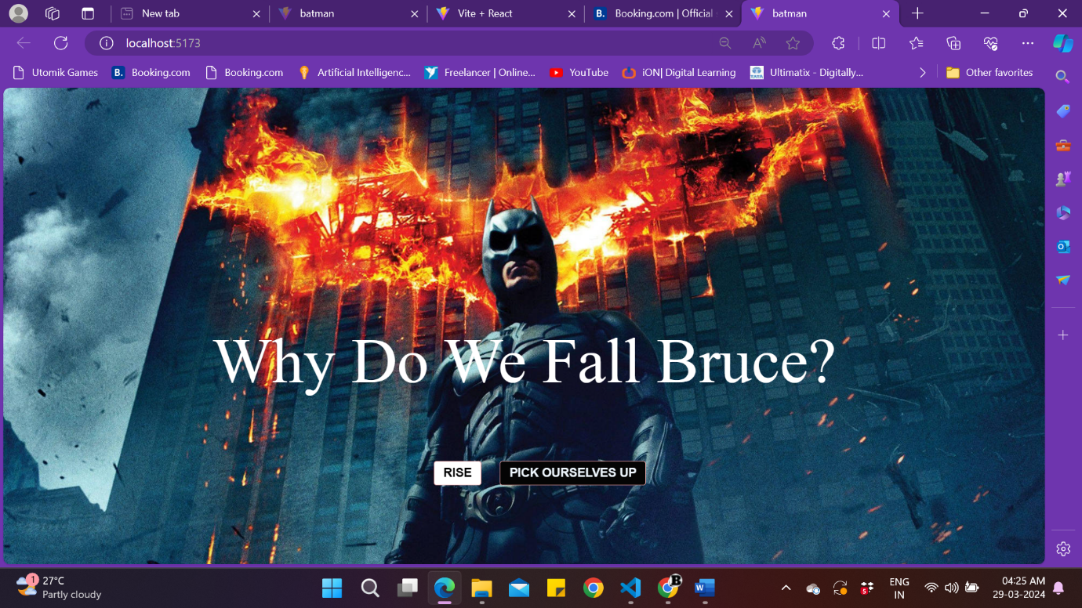

Day 2 [29-03-24]

Tutor Joe’s react tutorial:

* Covered topics regarding JSX, dynamic class name, conditional rendering, props.

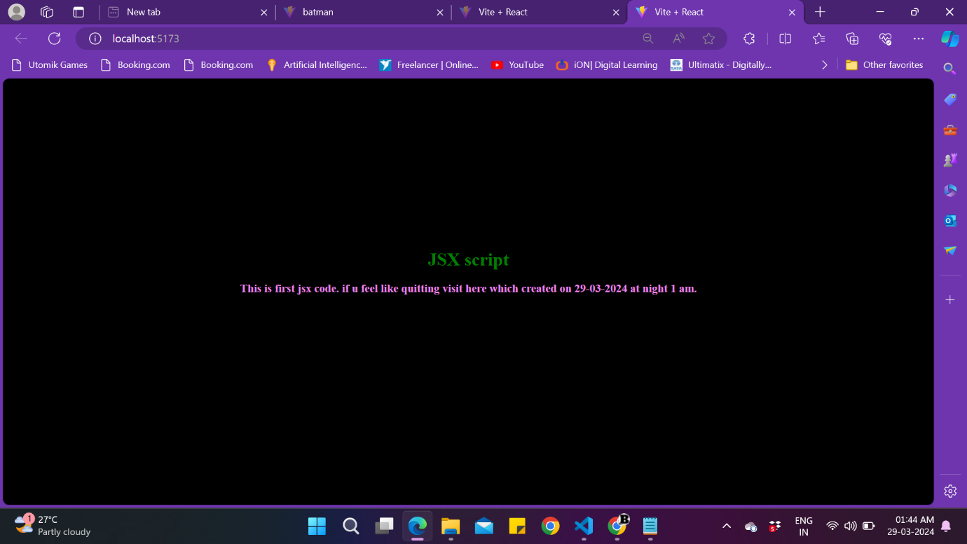

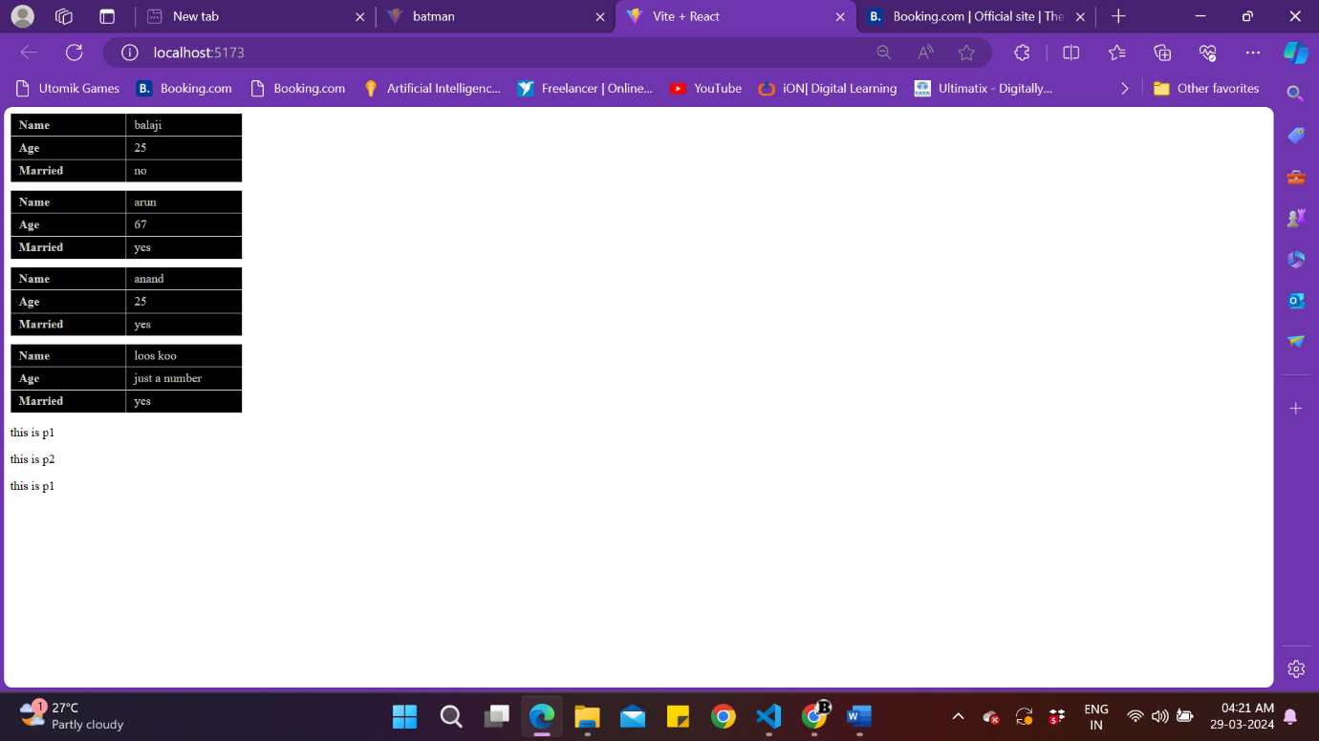

Day 3 [30-03-24]

Tutor Joe’s react tutorial:

* 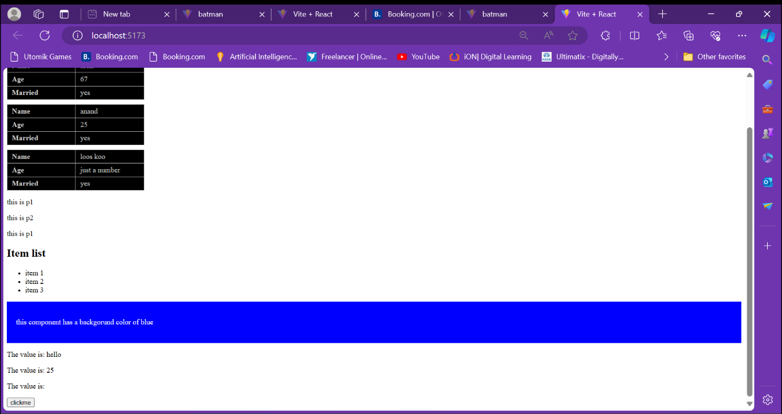Covered topics regarding props (one of, multiple Type, Array, children)
* 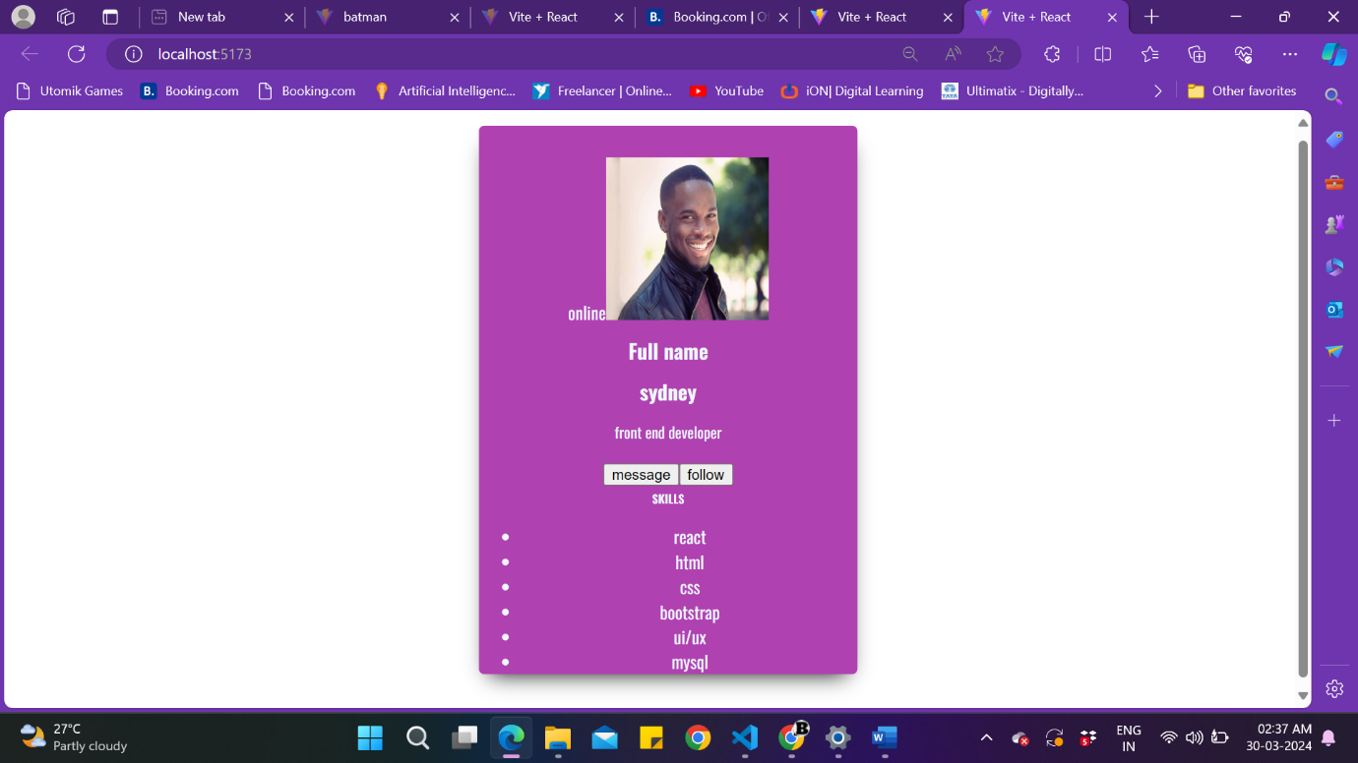In progress of creating user card using above covered topics.